**1) Design**

a. **Architecture Diagram**

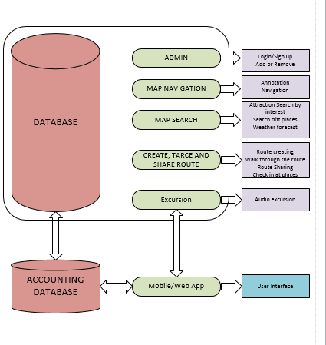

**b. Class Diagram**

Database

User Interface

Map Navigator

Annotation

Navigation

Tracking the route

Routes

Create route

Trace route

Share route

Check in at places

Map Search

Search by interest

Search differences places

Weather forecast

Search direction

**2) Features Implemented**

**a**. **Web Services**

i. Your own services

* [JSON-RPC](http://en.wikipedia.org/wiki/JSON-RPC)
* [JSON-WSP](http://en.wikipedia.org/wiki/JSON-WSP)
* [Web template](http://en.wikipedia.org/wiki/Web_template)
* [Web Services Description Language](http://en.wikipedia.org/wiki/Web_Services_Description_Language) (WSDL) from the [W3C](http://en.wikipedia.org/wiki/World_Wide_Web_Consortium)
* [XML Interface for Network Services](http://en.wikipedia.org/wiki/XML_Interface_for_Network_Services) (XINS) provides a [POX](http://en.wikipedia.org/wiki/Plain_Old_XML)-style Web service specification format
* [Web Services Conversation Language](http://en.wikipedia.org/wiki/Web_Services_Conversation_Language) (WSCL)

ii. Existing services/APIs

* Amazon Web service API
* Google API
* Foursquare API

**b.** **Database**

i. Your own data model/data sources

ii. Existing data model/data sources

The main aim of data models is to support the development of [information systems](http://en.wikipedia.org/wiki/Information_system) by providing the definition and format of data. If the same data structures are used to store and access data then different applications can share data. The results of this are indicated above. However, systems and interfaces often cost more than they should, to build, operate, and maintain. They may also constrain the business rather than support it. A major cause is that the quality of the data models implemented in systems and interfaces is poor. Here I have used oracle in order to connect to a database.

**3) Include Screenshots of the Features:**

Below is the screen shot of how my web app user interface looks like..

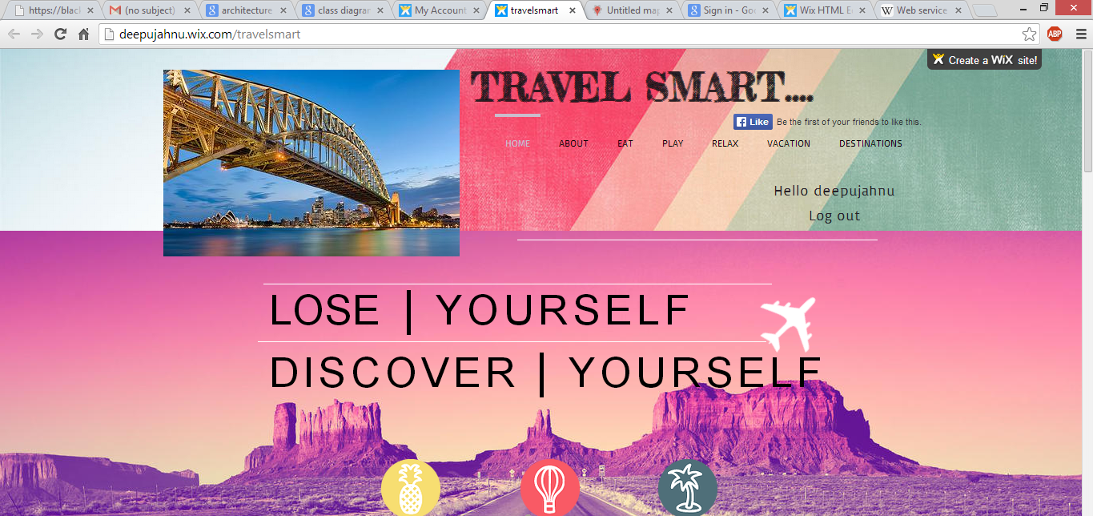

This is how my sign up page looks like

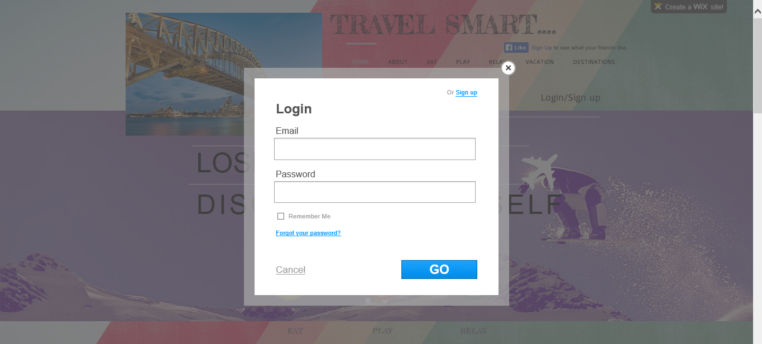

And the sign up page looks as follows

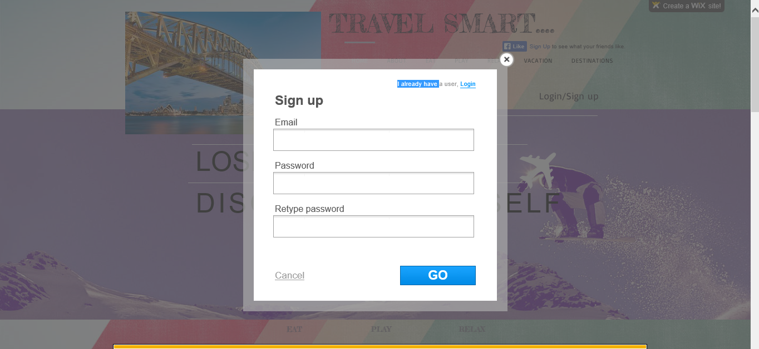

You can view the favorite tourist spots or most visited tourist spots on the home page and get their details and directions in one click.

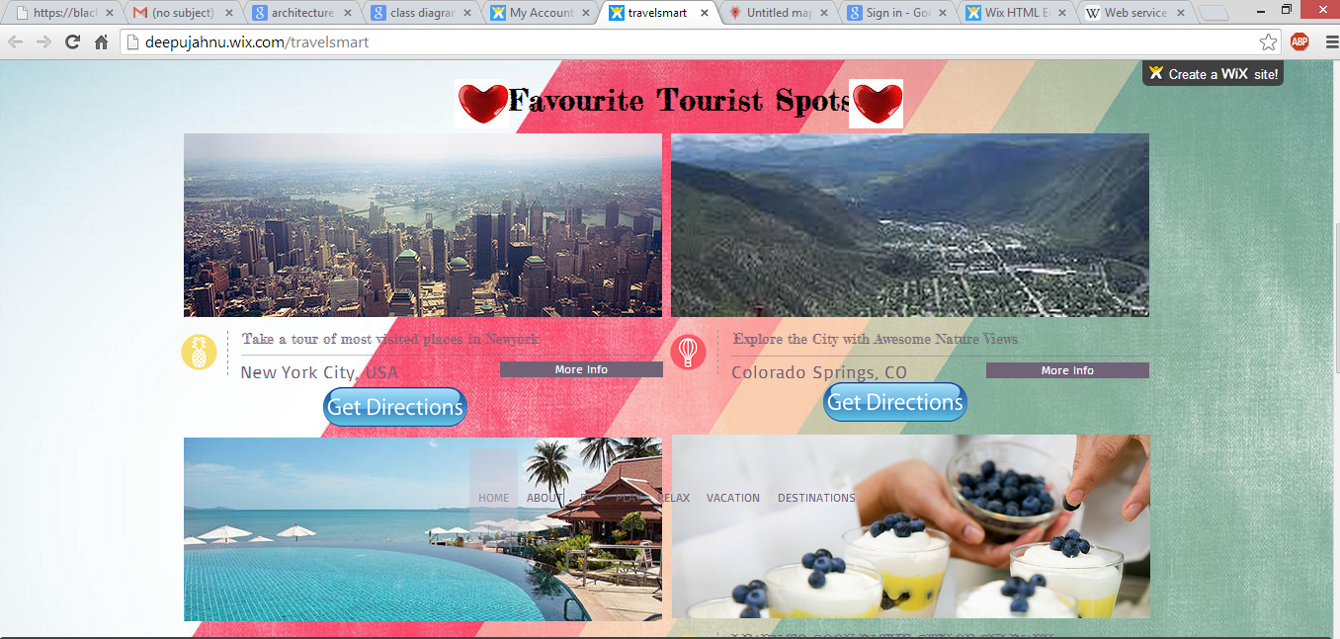

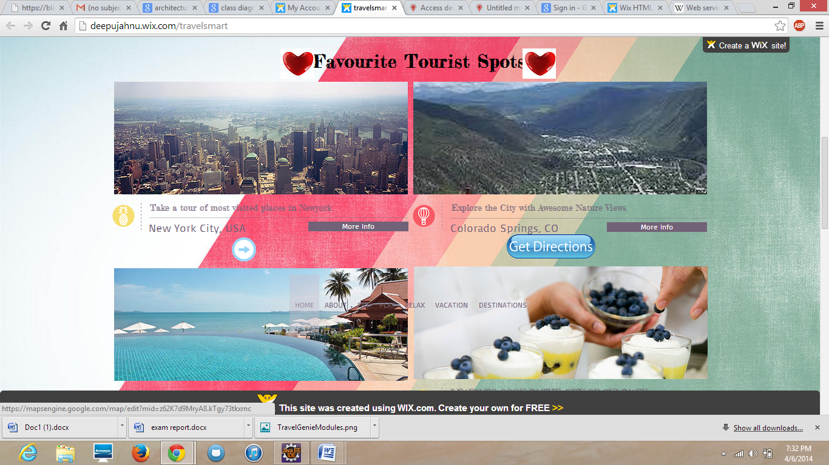

When you click the get directions shown in the above screenshot you will be redirected to the following page

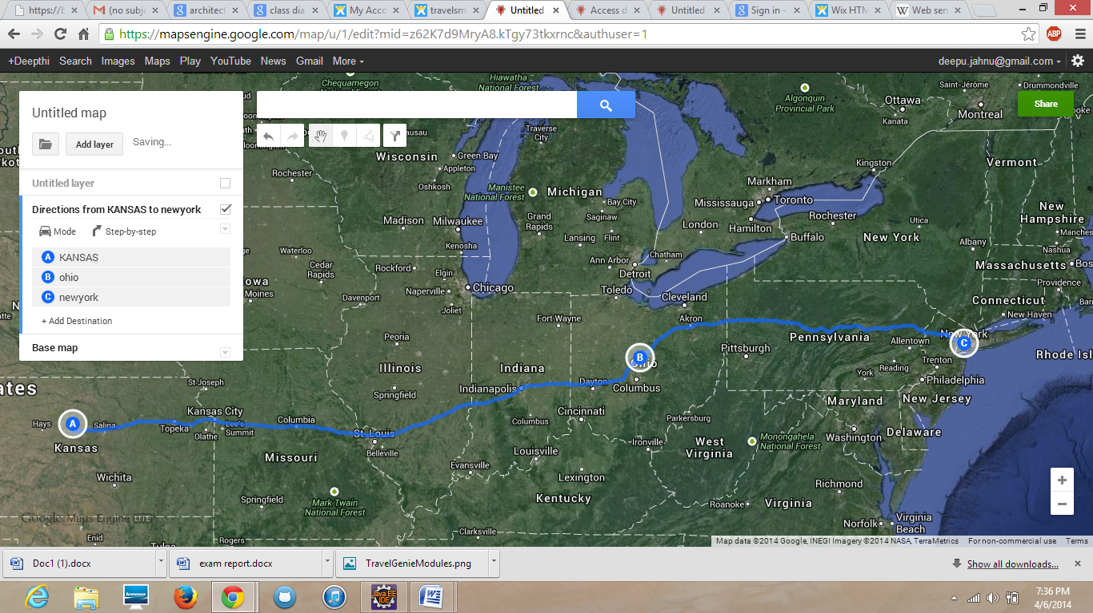

The above shows the map route from Kansas to New York via Ohio. The three places are marked and you can trace the route as well as share it with your buddies with the help of the share option in the top right corner…

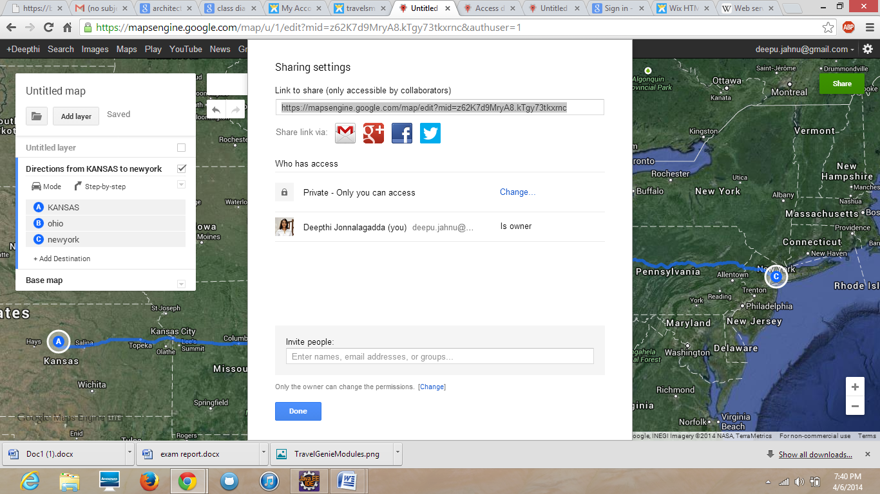

When you click the destinations icon in the home page you will be redirected to the page in the below screenshot.. Here you can view all the states in the USA

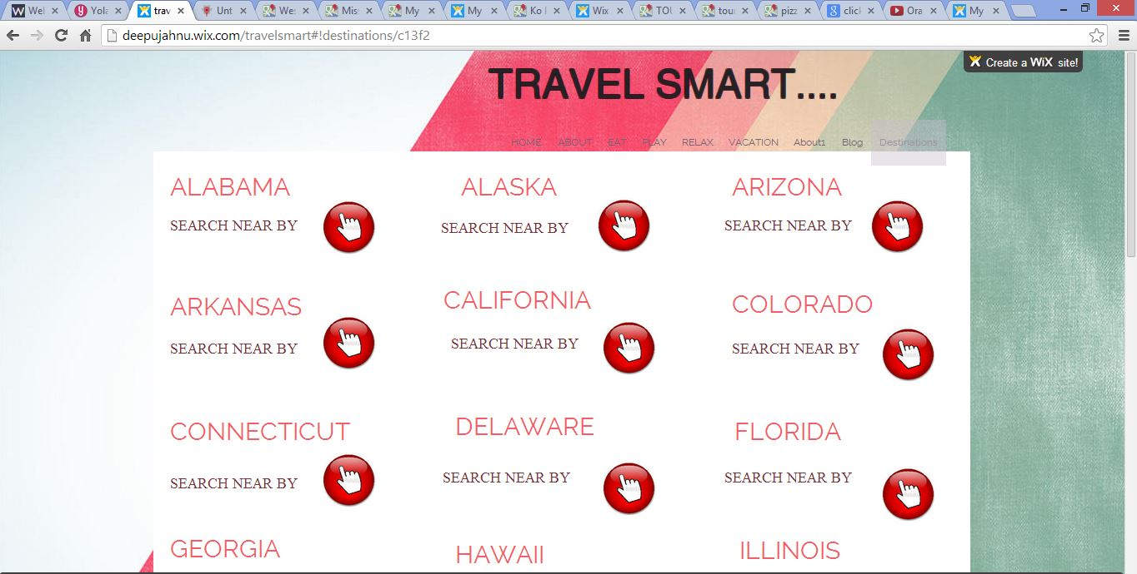

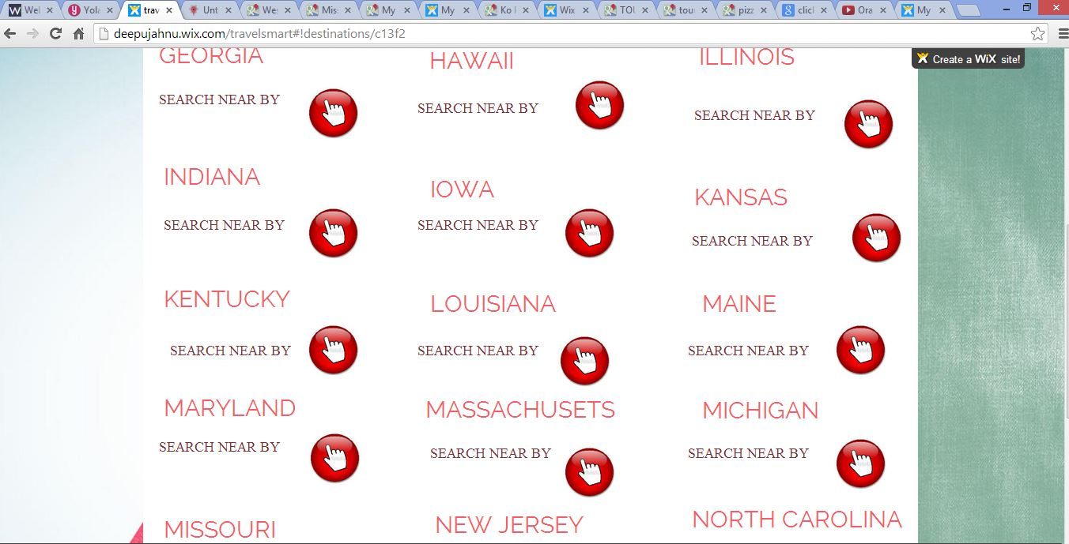

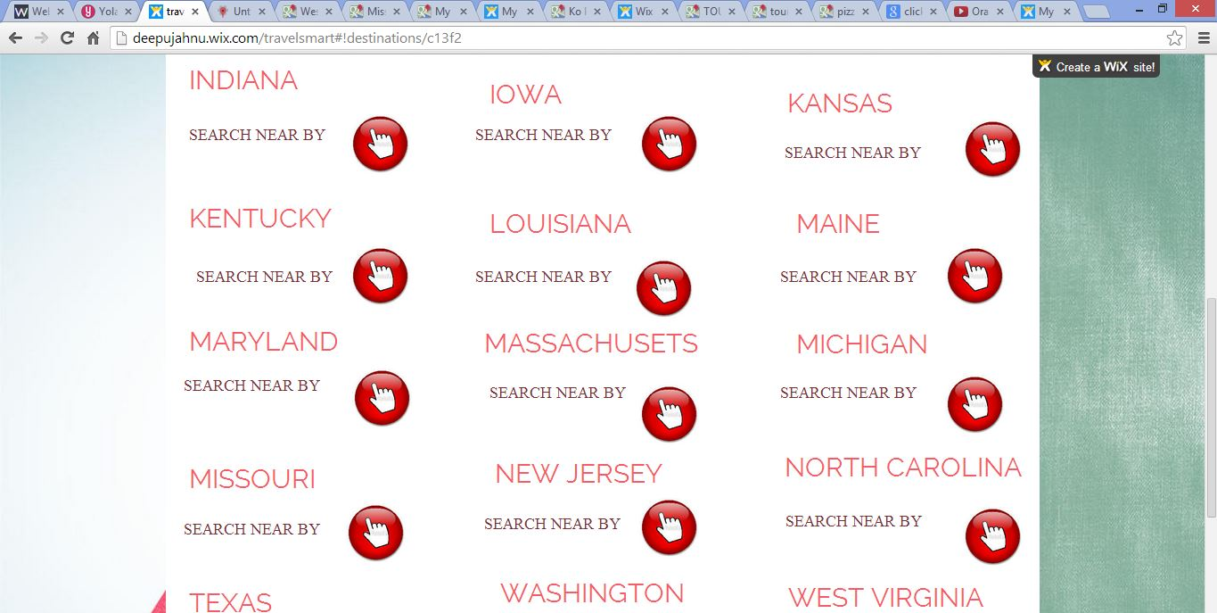

When you click the "click icon" in the above screen shot besides "search near by" you will be redirected to the following page where you can find anything or anyplace in a particular state.. for example if you click New York..

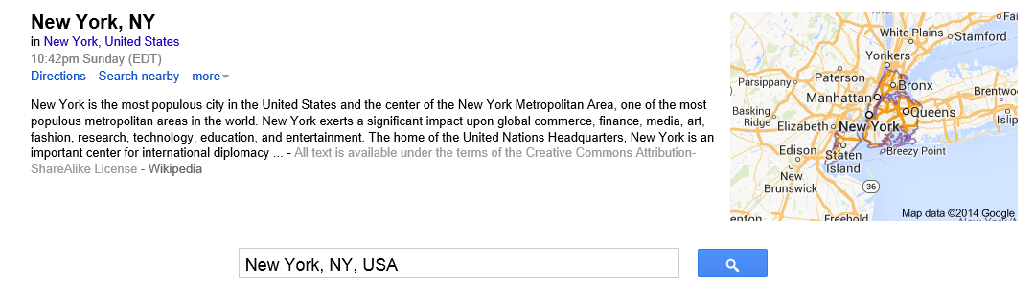

You can select the option search nearby in the above screen shot and find all the desired places. If for instance I search for tourism the screenshots look like below

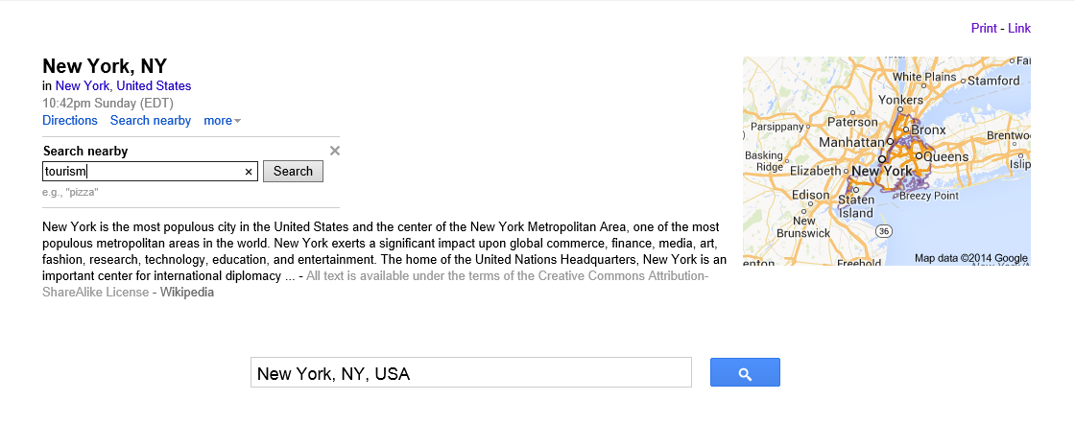

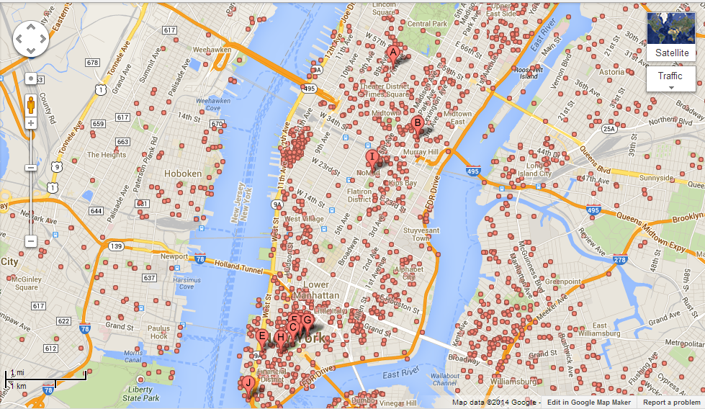

If I search for pizzas the following map will be displayed

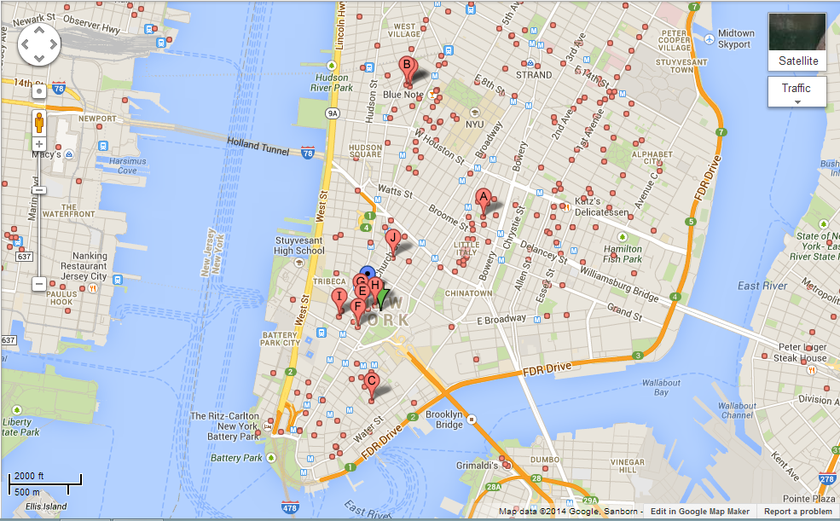

You can also find the directions from any place to anyplace. The below screenshot is from Kansas to New York.

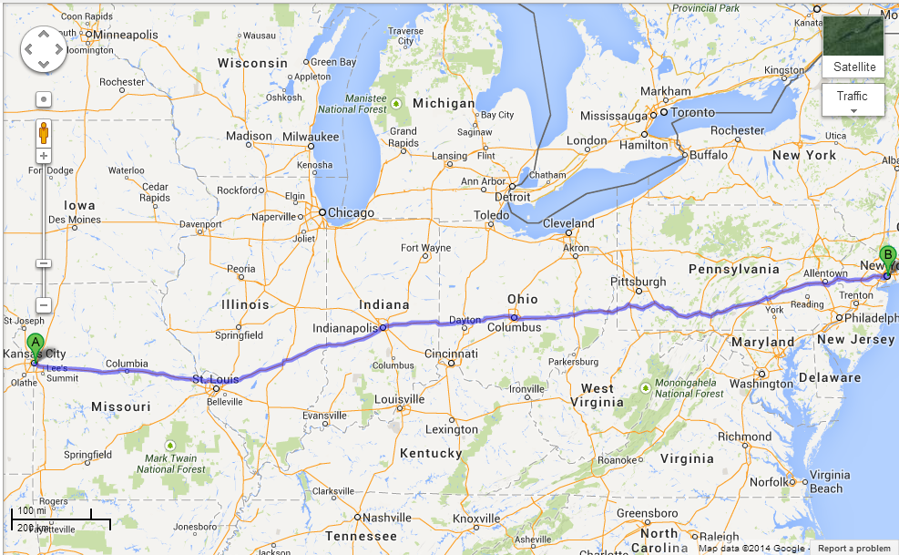

When you click the eat option in the home page following appear.. When you click the click button you can find all the restaurants in any place all over the world.

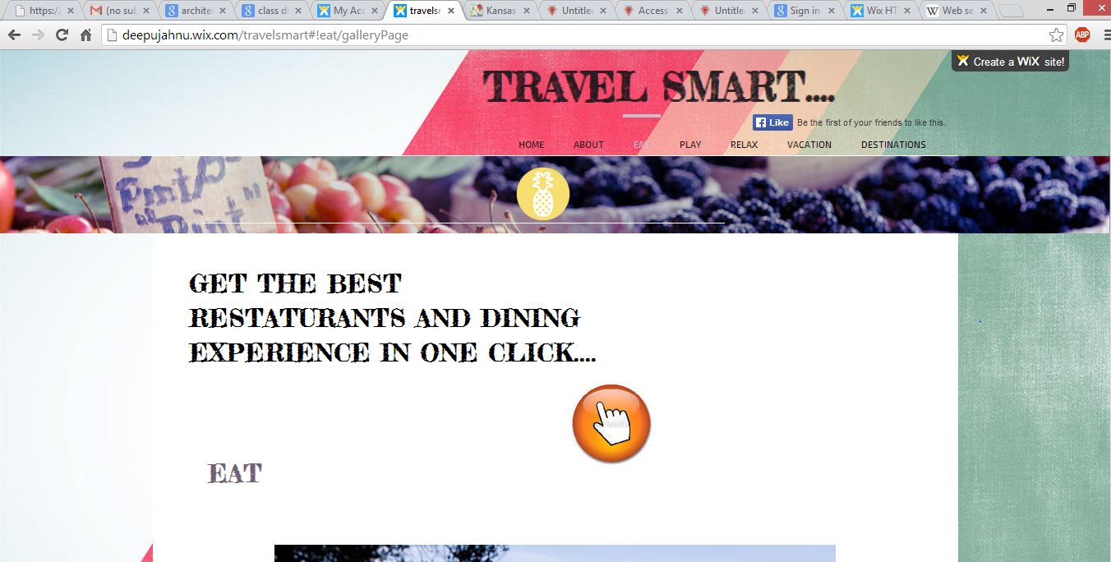

When you click the above button you will be redirected to the following page. I selected New York.

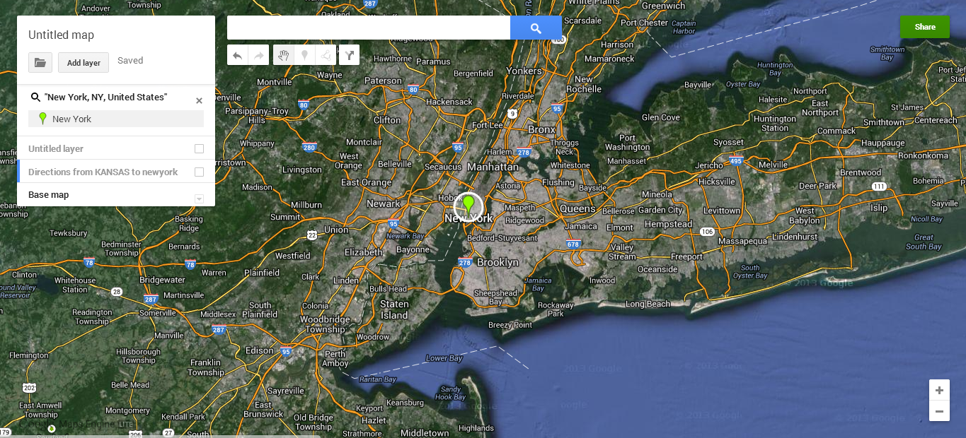

Now you will find all the restaurants in the New York city displayed.

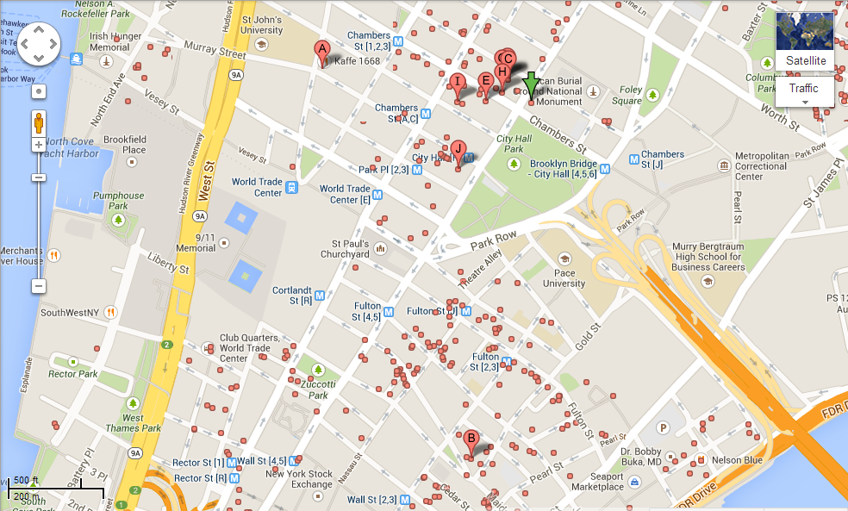

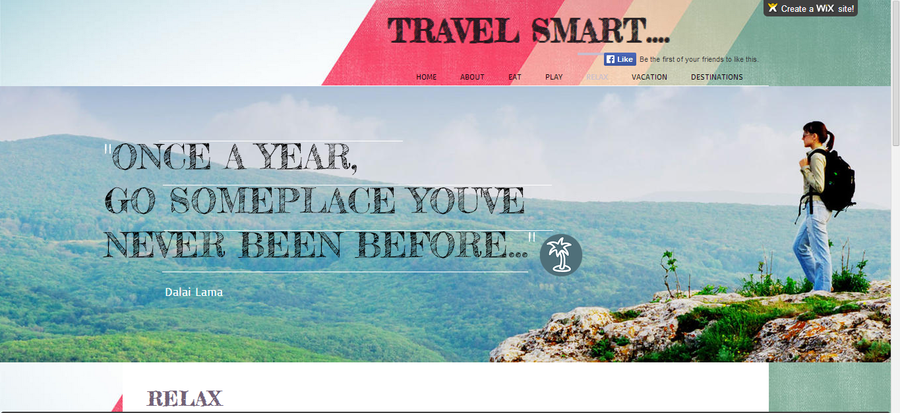

You can click the below button and get the guide to your desired place.

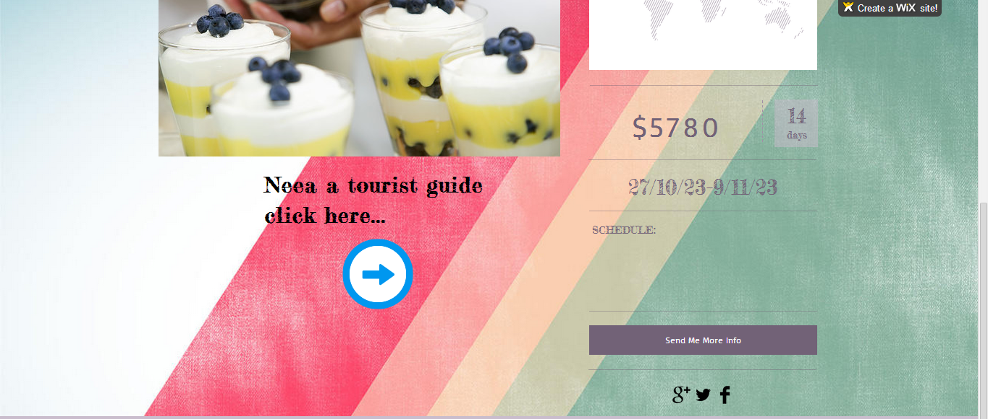



We can get the feedback from the users from the form shown below..

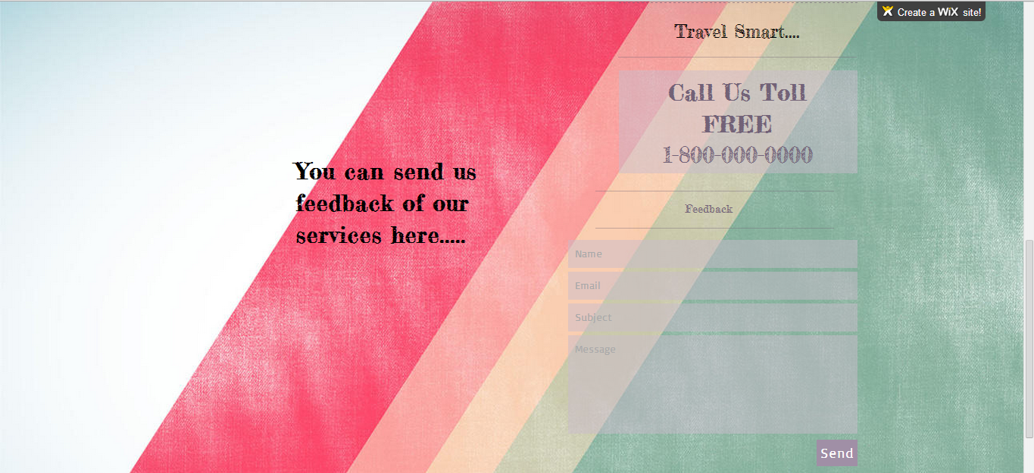

The users can share any route or anyplace from the share button provided on the top right corner of any page and also he can save his favorite routes and share it with his/her friends and also check-in at any place so that the users friends can also view the information about the place the user visited.

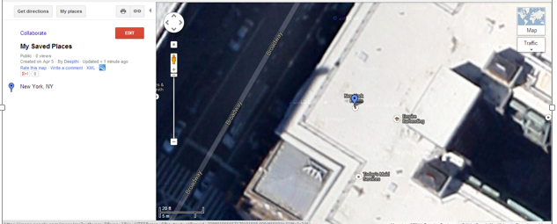

**4. Include all the Web Services and Web Site Url’s:**

Foursquare website https://foursquare.com/

Foursquare API https://developer.foursquare.com/start

Google [www.google.com](http://www.google.com)

YouTube [www.youtube.com](http://www.youtube.com)

**5. Include your mid-term Github URL**

**6. Limitations:**

The limitations are

- the web app is

**7. References**

Foursquare website https://foursquare.com/

Foursquare API https://developer.foursquare.com/start

Text-to-speech http://www.oddcast.com/home/demos/tts/tts_example.php

Google Developer Site https://developers.google.com/

Amazon Web Service API http://docs.aws.amazon.com/AWSECommerceService/latest/DG/Welcome.html /

Facebook Developer Site https://developers.facebook.com/